Chapter 9, Problem 42.

Calculate v_{o}(t) in the circuit in Fig. 9.49.

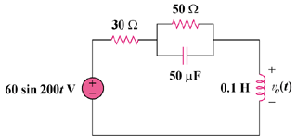

Figure 9.49
For Prob. 9.42.

